Deportations, Expulsions and Exiles
The Fourth Geneva Convention for the Protection of Civilians enjoins the occupying power to provide for the well being of the “protected persons” under its control for the duration of the occupation. Furthermore, the Convention states unambiguously in Article 49: “Individuals or mass forcible transfers, as well as deportations of protected persons from occupied territories to the territory of the Occupying Power or to that of any other country, occupied or not, are prohibited, regardless of their motive.” Article 76 adds that “protected persons accused of offences shall be detained in the occupied country and, if convicted, they shall serve their sentence therein.”
Although Israel has signed the Fourth Geneva Convention, the government denies that it applies to the West Bank and Gaza Strip. On the contrary, Israel enforces article 112 of the 1945 Emergency (Defense) Regulations, which was promulgated by the British mandatory government. According to Article 112, which permits deportation: “The High Commissioner shall have the power to make an order …for the deportation of any person from Palestine. A person in respect of whom a Deportation Order has been made shall remain out of Palestine so long as the order remains in force.” However, prior to the end of the mandate in 1948, the British revoked the Emergency Regulations.
Israel has used its expulsion policy as a political tool, in order to prevent an indigenous Palestinian leadership from arising. For Palestinians, deportations seem an integral part of the Israeli effort to systematically wipe out the Palestinian Arab leadership in the occupied territories. Exile physically eliminates the leaders who can rally the citizens to resist the occupation and deters the growth of an alternative, natural and open political leadership that could express their political rights and aspirations. Moreover, expulsion satisfies the Israeli public’s demand for vengeance.
Prior to 1980, the Israeli army transported deportees to the borders of either Jordan or Lebanon before the deportees’ could contact a lawyer to obtain a stop order from the Israeli High Commission of Justice. Since 1980, deportees have had 48 hours to appeal to a military review committee and then to the High Court. The appeals committee consisted of a military judge and army officers who lacked independent status, since they were appointed by the military government. Those committees rarely challenged deportation orders. In practice, security officers insisted that evidence be hidden from deportees and their defense lawyers; charges were hardly ever stated. In any event, the committees did not constitute formal courts of law and only had advisory power. According to records, only 6 people appealed successfully to the military committee. Nonetheless, three of the six were deported anyway, when the Israeli government overruled the committee. Such steps postponed expulsion, but scarcely blocked it.
The Israeli government also deported prisoners jailed for long periods of time or prisoners in need of urgent medical attention; expulsion often proved the only way to get out of prison. Moreover, some prisoners had completed their sentences, but the Israeli government still refused to release them and used expulsion as a tool to deal with such political prisoners.
The High Court rarely challenged the government’s security arguments and tended to decide on procedural, rather than substantive, grounds. Further, the Israeli government has only formally rescinded deportation twice; for the mayor of Nablus in 1979 and for 11 persons ordered expelled in January 1992.
Despite the slim prospects for success, nearly all deportees attempted to utilize the two-step appeals process. However, many often dropped their appeal prior to the Court’s ruling, as a form of protest against the legality of the military panel, their lawyers’ inability to review evidence, and/or the High Court’s refusal to base its decision on the Geneva Convention.
1948-1967
The Palestinian Exodus: The Palestinian refugee problem did not arise from a conflict in which, as Zionists claim, Israeli forces overcame overwhelming odds against invading Arab armies while nearly 1 million Palestinians left voluntarily. The evidence is clear that Israeli forces followed a planned and effective strategy of ethnic cleansing against the Palestinian people. The results of this forced exodus can be seen in Palestinian refugee camps across the Arab world and in the Palestinian Diaspora. Israel’s ethnic cleansing continues today in the form of discriminatory residency policies, building codes in Jerusalem and house demolitions, movement restrictions and economic blockades, military terrorism and discriminatory land and water policies within the Occupied Palestinian Territories.
A Land without a People…the Zionist Myth: It was the Zionist ideal to create a Jewish homeland in Palestine. But the region was already populated with a history stretching back thousands of years. In an effort to win the acceptance of British and colonial powers as well as the world Jewry, Zionists characterized Palestine as a land without a people for a people without a land, propagating a convenient myth of an empty Palestine awaiting settlement. However, as evidenced from the atrocities committed by Israeli forces in the 1948 War in order to terrorize Palestinian inhabitants into flight from their homes, nothing could have been further from the truth.
The British Role: In November 1917 while the territory was under British occupation, Britain acceded to Zionist demands and declared their support for the establishment in Palestine of ‘a national home for the Jewish people,’ provided there were proper safeguards for ‘the existing non-Jewish communities’. Over two decades of British occupation, the mandatory authority facilitated Jewish immigration and state and economic infrastructure in Palestine at the expense of the indigenous Palestinian inhabitants. It should be noted that the historic Jewish population in Palestine did not necessarily support these demands—one indigenous Jewish leader described Zionism as “evil”.
Israeli Terror and Dispossession: Jewish underground terrorist groups such as Haganah, Irgun and Stern undertook the task of terrorizing the Palestinian people by slaughtering families and sacking and destroying villages. No less than 34 massacres were committed in only a few months: Al-Abbasiyya, Beit Daras, Bir Al-Saba', Al-Kabri, Haifa, Qisarya…among many others. These attacks (so-called Plan D) aimed to erase the existing Palestinian presence and population. Israeli forces killed an estimated 13,000 Palestinians and forcibly evicted 737,166 Palestinians from their homes and land. 418 Palestinian villages were entirely depopulated and some 50% of Palestinian villages were destroyed in 1948 and many cities were cleansed of their Palestinian population including Acre, Bir Al-Saba', Bisan, Al-Lod, Haifa, Jaffa, Lyda, Al Majdal, Al Ramle Safad, Tiberias and West Jerusalem.
The Israeli government of the time pursued a policy of non- compromise, in order to prevent the return of the refugees "at any price" (as Ben Gurion himself put it), despite the fact that the UN General Assembly had been calling for this since 11 December 1948. Their villages were either destroyed or occupied by Jewish immigrants, and their lands were shared out between the surrounding kibbutzim. The law on "abandoned properties" - which was designed to make possible the seizure of any land belonging to persons who were "absent" - "legalized" this project of general confiscation as of December 1948. Almost 400 Arab villages were thus either wiped off the map or Judaised, as were most of the Arab quarters in mixed towns. According to a report drawn up in 1952, Israel had thus succeeded in expropriating 73,000 rooms in abandoned houses, 7,800 shops, workshops and warehouses, 5 million Palestinian pounds in bank accounts, and - most important of all - 300,000 hectares of land.
1967-1972
During the first phase, post the 1967 Six Day War, expulsions decimated the pro-Jordanian elite and hampered the growth of the nationalist activists. Those who organized protests against the annexation of east Jerusalem to Israel and opposed changes in the religious, educational, and legal systems were singled out, especially a three member committee that coordinated political resistance, the President of the Islamic Council, the mayor of Jerusalem, and the director of the Maqasid Islamic charitable hospital.
Ongoing unrest in schools and general strikes by merchants were countered by expulsion as well as arrests, fines, curfews, shops, closures, and travel restrictions. Deportees included the mayor of Ramallah; the deputy mayor of Jenin; the head of Ramallah’s Red Crescent society; and dozens of teachers, doctors, lawyers, engineers, labor leaders, and journalists.
In contrast, nearly all those who were expelled from Gaza were men who fought in the 1968-1970 Intifida. Expulsions in Gaza peaked at 146 in 1970 and 144 in 1971.
1973-1984
In mid-1973, pro-P.L.O. activists formed the clandestine Palestinian National Front (PNF.), which provided an umbrella for groups that sought negotiations based on Palestinian statehood alongside Israel and recognition of the of the P.L.O as the Palestinians representative. However, Israel reacted by attempting to destroy the PNF. The Israeli campaign began on December 10, 1973, international human rights day, when the Israeli government deported eight leaders, including the mayor of Al-Birah, three Communists, and a member of Jerusalem’s Islamic Council. Each expulsion triggered demonstrations and heightened tension. Israel expelled four people in 1974 who helped organize a petition drive to the Arab League in October of 1974 that backed the P.L.O. as the Palestinian diplomatic representative including the deputy mayor of Halhul. After student demonstrations and business strikes in November 1974, five prominent residents were deported, including members of Ramallah’s municipal council and chamber of commerce and the President of Berzeit University.
During the winter of 1975-76, the West Bank witnessed far-reaching civil disobedience, which peaked as municipal elections neared. The Israel government exiled two of the candidates it perceived as promising Palestinian political leaders. The army expelled the two fifteen minutes before a High Court judge was to hear their appeal.
For the next nine years, the Israeli government continued to use expulsion whenever it perceived that a Palestinian could be a potential political leader, including the mayors of Nablus and Halhul. Both elected leaders were powerful symbols of Palestinian nationalism. Their expulsions were demanded by the Israeli right and by settlers.
The Israeli government summarily deported mayors Fehd Qawasmeh of Hebron and Muhammad Milhem of Hulhul of May 3, 1980, before they could protest or take legal action. Both mayors promoted dialogue with Israeli peace groups, but the government charged them with inciting Palestinians to kill five settlers in Hebron. However, the mayors had no connection to the attacks and they were denied the opportunity to appeal. The High Court demanded that the Israeli military provide cause why the expulsion should not be rescinded and recommended that the mayors return home to file their appeals. Later, when the two mayors lost their appeals, the High Court still urged the government to let them stay, but they were re-expelled the next day.
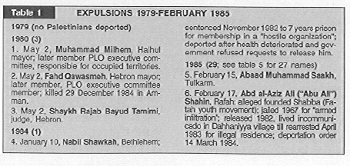

1985-1987
The use of deportation to control Palestinian political life resumed in 1985 when Yitzhak Rabin became Defense Minister. He deported 47 Palestinians in the next 2.5 years in contracts to the six expulsions in the previous seven years. Those expulsions were part of Rabins’s “Iron Fist” policy, which also included large-scale house demolitions and administrative detentions. He targeted secular nationalist and leftist activists (Fatah, Democratic Front, Popular Front), especially municipal councilors, journalists, and trade union leaders. He expelled student leaders, members of universities’ elected student councils and activist in the Shabiba, the (then legal) youth movement affiliated with Fatah.
Rabin singled out former prisoners, who were among 1,150 long-term prisoners freed in may 1985 in exchange for three Israeli soldiers detained by the Popular Front-General Command in Lebanon. 605 of those prisoners were freed in the West Bank and Gaza, but Rabin expelled 19 for not holding valid identification cards and deported a dozen for allegedly resuming political activities.
In the fall of 1987, after Islamic Jihad began to attack military personnel, the Israeli government arrested one of its founders, Shaykh Abd al-Aziz Awdah and sought to expel him, which galvanized violent protests in Gaza.
The Israeli government even expelled peace activist Mubarak Awad, director of the Palestinian Center for the Study of Nonviolence. Awad, an outspoken pacifist, catapulted into international prominence when the government revoked his residency in September 1987. His deportation in June 1988 proved embarrassing politically for Israel, because he countered the Israeli propaganda of the deportee as a terrorist.
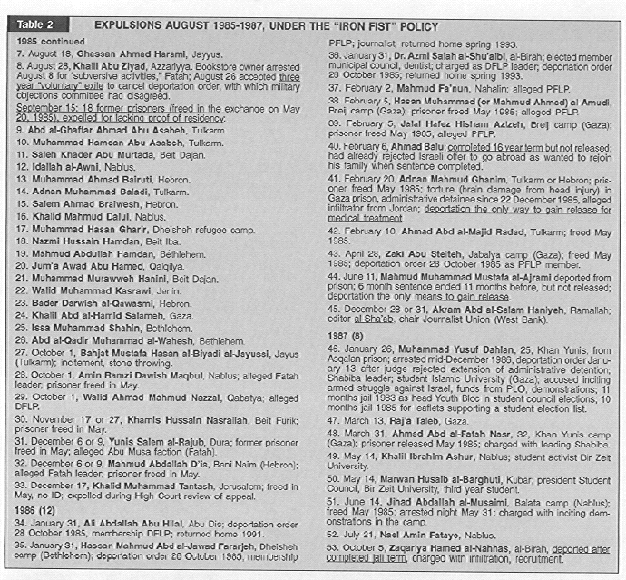
1988-189
Expulsions accelerated with the onset of the Intifadia, which began December 9, 1987. The Israeli government viewed deportation as an effective tool to quell the Intifida, because deportations were considered an emotional shock. In 1988, 36 persons were expelled to Lebanon for organizing and participating in uprising, although none were charged with terrorist or violent acts. Most were secular nationalists, but one came from Hamas and another from Islamic Jihad.
An example, physics professor, Taysir Aruri, was arrested shortly after he signed a statement with Israeli and Palestinian academics that called for mutual recognition and peace. Aruri was expelled despite protests that peaked when 1,200 physicists, including 18 Noble laureates, petitioned: “It is extremely disturbing that a man of Aruri’s long-time, well-known and outspoken moderate views is considered by Israel to be a candidate for deportation.”
In another instances, the government deported six residents of Baita village, shortly after an Israeli girl was killed, while hiking through the village. Even though the girl was shot accidentally by her armed Israeli escort and the military prosecutor did not seek expulsion of any villagers; however, he succumbed to Israeli settlers demands for punitive actions.
Palestinians were not daunted by the expulsions, since they placed them in the context of their fundamental national struggle. The U.N. Security Council and the International Community criticized Israel for deporting Palestinians. Moreover, an U.N. resolution passed, condemning expulsions.
26 people were deported during 1989.
Additionally, during this period, support for the transfer or mass expulsion of Palestinians grew in Israel. Israeli polls showed that 38% favored transfer in early 1989 whereas, by November 1989, 52% supported mass deportation if there was no peace accord.
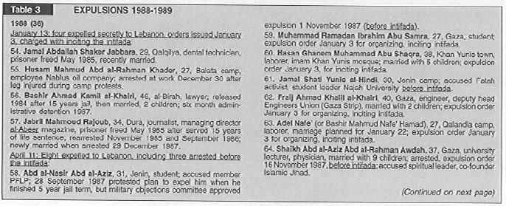
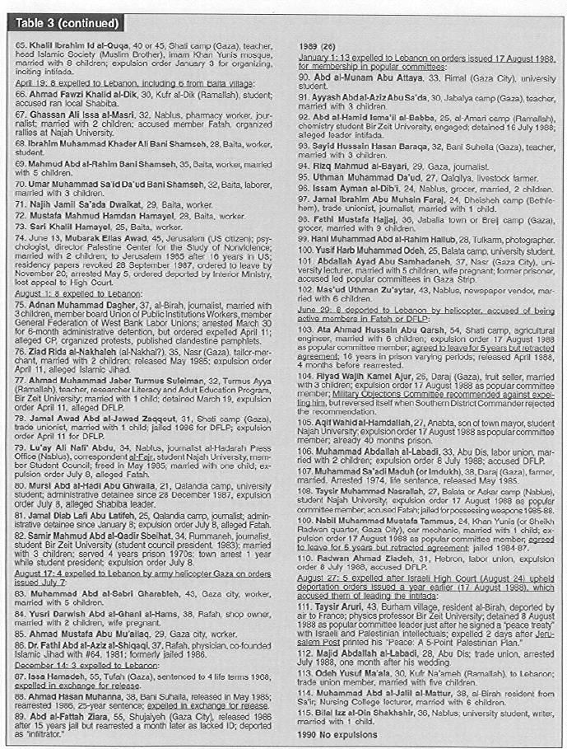

1990-1993
As tensions mounted during the Gulf Crises and War, Israel expelled more Palestinians. In 1990, four members of Hamas were expelled after nearly a 1,000 were rounded up. In March of 1991, the Israeli government retaliated against a series of knifings by expelling four persons allegedly connected to Fatah, despite the fact that none had connections to the knifings.
Moreover, in the midst of student council elections at Al-Najah National University in July 1991, the Israeli army besieged the campus, claiming that armed men had taken refuge there. Nearly 3,000 people were trapped on the campus for four days, until the Palestinian leader Faisal Husseini negotiated deal, which called for the expulsion of 6 Palestinians for 3-years. Husseini said, “The price of getting the University crisis was high, deporting Palestinians is something we reject in principle.
In 1991 Israel’s decided to expel four Palestinians from Gaza. Further in 1992, the Israeli government announced its intention of expelling 12 Palestinians after an Israeli settler was shot in Gaza. None of the 12 were charge with the killing of the settler; in fact 6 of them were already in jail at the time of the shooting.
As soon as Palestinians kidnapped Sergeant Nissim Toledano, an Israeli border policeman, in Lod on December 13, 1992, the army rounded up 1600 members of Hamas and Islamic Jihad. When Toledano’s body was found, the army blindfolded and handcuffed 418 detainees, loaded them on 22 busses, and drove them to the Israeli held territory in south Lebanon. They were held up for 18 hours on the busses, with their hands and feet tightly bound, before they were forced to walk into Lebanon on December 17.
The expellees were never linked to the assassination of Toledano. Indeed, when four persons were arrested in June 1993 and charged with his murder, security officials conceded that those Palestinians had acted on their own-with no prior contact with Hamas or Islamic Jihad.
More than 109 of the expellees were students, teachers, professors, or administrators at universities or schools. The expellees also included 99 laborers; 65 self-employed framers or shopkeepers; at least 21 physicians, pharmacists, and engineers; and more than 19 religious preachers.
The Israeli government did not expect the Lebanese government to block the entry of the expellees. In the past, the Israeli army provided deportees with $50 and a satchel of clothes and ordered them to walk north into Lebanese territory. Soldiers closed the gates behind them and threatened to shoot if the expellees tried to return. However, during 1992, the Lebanese army had assumed control over the area directly north of Israel’s self-imposed zone. Caught between the Israeli and Lebanese armies, the expellees pitched tents to form the Awda (Return) Camp.
The Red Cross and the U.N. provided 53 tents and numerous blankets, but were quickly prevented by Israel from offering further services and assistance. The expellees were forced to smuggle food and medicine from nearby Lebanese villages. They lacked permanent sources of fresh water, aside from seasonal stream, and had no waste facilities. Skin disease, stomach ailments, and chest infections spread quickly, despite efforts by expellees’ doctors to treat them. In late July, 87 expellees marched toward Israeli lines demanding their evocation for medical treatment.
On December 16, the Israeli cabinet approved an amendment to the Emergency Regulations, which granted the military commanders “the authority to issue orders without prior notice, to expel inciters for a period not to exceed two years.”
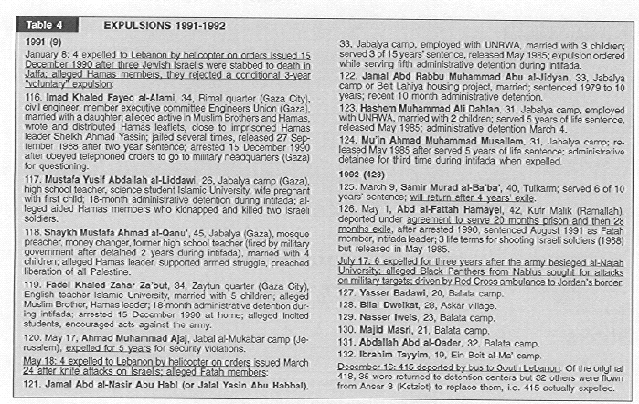
1993-2001
From 1993 to 2001, Israel did not deport anyone during its participation in the Oslo Peace process.
2002-Present
After a five-week siege in Bethlehem’s Church of the Nativity, one of Christian’s holiest shrines, a European-brokered deal called for the deportation of thirteen Palestinians to several European countries. The deportees boarded a bus from Bethlehem that took them to Ben Gurion airport from where a British military aircraft flew them to Cyprus from which they later would be deported to third countries in Europe and perhaps Canada.
Another 26 Palestinians who were in the Church have been forcibly transferred from Bethlehem to Gaza.
Any such agreement is unlawful, as it violates the provisions of articles 49 and 147 of the Fourth Geneva Convention prohibiting unlawful transfers and deportations of protected persons. Under article 147, any such transfers and deportations amount to a grave breach, namely war crimes.
Recently, in July, the Israeli cabinet has endorsed the idea that it can save Israeli lives if it expels relatives of bombers from the West Bank to the isolated and enclosed city of Gaza. By acting against innocent family members, the Israeli government would be imposing a policy of collective punishment against innocent individuals.
Again, support for the transfer or mass expulsion of Palestinians is popular among Israelis. According to Netanyahu, “We must complete the purification of the area and clean it out totally of all fighting forces and arms. The Prime Minister and the government began this mission, but it has not yet been completed." Netanyahu's usage of the word purification is significant, as it shows the long-standing goal of Zionists to embark on the ethnic cleansing of Palestinians. Such an agenda is supported by 46% of the Israeli population and over 60% wish the government would urge Israeli Arabs to leave the country. Another fanatical party in Sharon's government, the Molodet party headed by Benny Elon, the Minister of Tourism, have for long ran for elections under the platform that "only transfer will bring peace".
Additionally, it is now Israeli policy via an order issued by Interior Minister Eli Yishai (Shas) to prevent the entry into Israel of anyone suspected of being a supporter of the Palestinians is being carried out in full and to the letter; and it is creating a growing number of ambassadors of ill will.

Sources:
http://www.palestinemonitor.org
http://www.apo.org.au/webboard/items/00047.shtml
http://www.salam.org/return2000/jmassad.html
http://www.badil.org/Law/Human_Rights/AI_Policy.htm
http://www.globalexchange.org/campaigns/palestine/refugeeFacts.html
http://www.ahram.org.eg/weekly/2000/472/focus1.htm
http://www.ameu.org/uploads/vol26_issue5_1993.pdf
www.lawsoceity.org

